Task 9: Alignment and Display

Aligning Elements in CSS and Display Properties
CSS provides several ways to align elements on a web page, and the display property plays a crucial role in how elements are rendered. The most common display values include block, inline, inline-block, and flex. Each of these determines how the element behaves in the layout.

CSS Display Properties
- Block (display: block): An element with this property takes up the full width of its container. It starts on a new line and stretches to the width of the container.
- Inline (display: inline): An element with this property does not start on a new line and only takes up as much width as necessary.
- Inline-block (display: inline-block): This property allows an element to behave like an inline element (not starting on a new line) but still respects width and height settings like a block element.
- Flex (display: flex): A flexible layout model that allows elements within a container to be aligned and distributed using powerful alignment properties.

Alignment Techniques in CSS
- Text Alignment: Use the text-align property to align text horizontally within its container.
- Vertical Alignment: Vertical alignment of inline or table elements can be done using vertical-align.
- Flexbox Alignment: The flexbox layout model (display: flex) provides a variety of ways to align elements both horizontally and vertically.

Example HTML Document with Alignment Techniques
<!DOCTYPE html>
<html lang="en">
<head>
<meta charset="UTF-8">
<meta name="viewport" content="width=device-width, initial-scale=1.0">
<title>Alignment and Display Properties</title>
<style>
/* Basic styles for the body */
body {
font-family: Arial, sans-serif;
padding: 20px;
}

/* Block-level element */
.block {
display: block;
background-color: lightblue;
padding: 10px;
margin-bottom: 20px;
}

/* Inline element */
.inline {
display: inline;
background-color: lightgreen;
padding: 10px;
}

/* Inline-block element */
.inline-block {
display: inline-block;
background-color: lightcoral;
padding: 10px;
width: 200px;
margin-right: 10px;
margin-bottom: 20px;
}

/* Flexbox container */
.flex-container {
display: flex;
justify-content: space-between; /* Distribute items with space between them */
align-items: center; /* Vertically center the items */
background-color: lightgray;
padding: 10px;
}

/* Text alignment */
.text-left {
text-align: left;
background-color: lavender;
padding: 10px;
margin-bottom: 20px;
}

.text-center {
text-align: center;
background-color: lavenderblush;
padding: 10px;
margin-bottom: 20px;
}

.text-right {
text-align: right;
background-color: lightgoldenrodyellow;
padding: 10px;
margin-bottom: 20px;
}

/* Vertical alignment using inline elements */
.inline-vertical {
vertical-align: middle;
background-color: lightpink;
height: 100px;
display: inline-block;
padding: 10px;
}

img {
vertical-align: middle;
width: 50px;
height: 50px;
}

</style>
</head>
<body>

<h1>Alignment and Display Properties in CSS</h1>

<!-- Block-level element -->
<div class="block">
This is a block-level element. It takes up the entire width of its container.
</div>

<!-- Inline element -->
<span class="inline">This is an inline element.</span>
<span class="inline">It only takes up the width it needs.</span>

<!-- Inline-block element -->
<div class="inline-block">
This is an inline-block element.
</div>
<div class="inline-block">
It respects width and height but stays inline.
</div>

<!-- Flexbox alignment -->
<div class="flex-container">
<div>Item 1</div>
<div>Item 2</div>
<div>Item 3</div>
</div>

<!-- Text alignment -->
<div class="text-left">This text is aligned to the left.</div>
<div class="text-center">This text is centered.</div>
<div class="text-right">This text is aligned to the right.</div>

<!-- Vertical alignment using inline-block -->
<div class="inline-vertical">
Text vertically aligned with an image:
<img src="https://via.placeholder.com/50" alt="Placeholder Image">
</div>

</body>
</html>

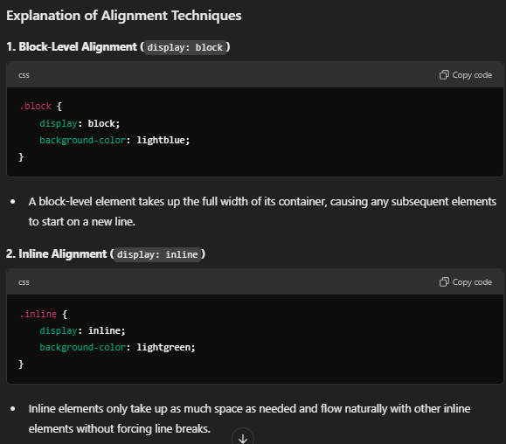
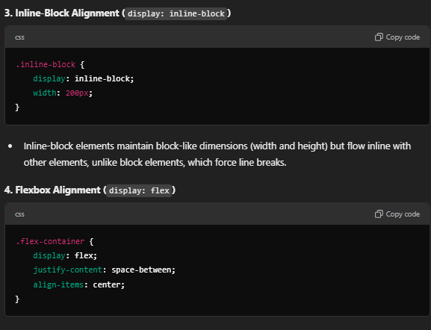
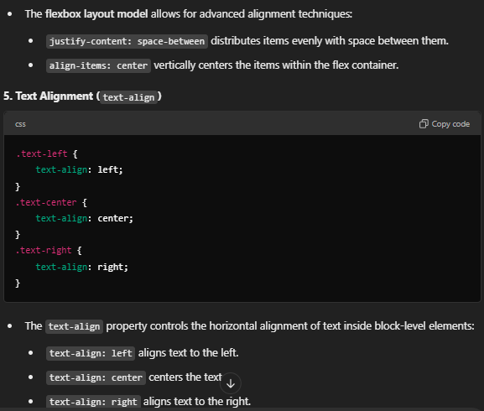
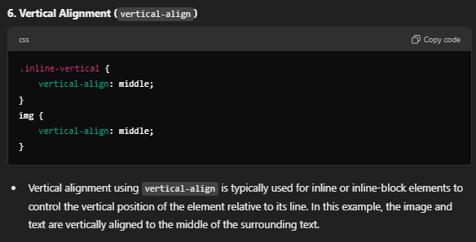

Summary of Display Properties and Alignment
- Block elements (display: block) take up the full width and force line breaks.
- Inline elements (display: inline) only take up as much width as necessary and stay inline with other elements.
- Inline-block elements (display: inline-block) allow setting dimensions but still flow inline with other elements.
- Flexbox (display: flex) is a powerful layout model that provides more control over alignment and distribution of space within a container.
By combining these display properties with various alignment techniques (like text-align and vertical-align), you can effectively control the layout and positioning of elements in a web page.

